SURFACE PHENOMENA AND FROTH FLOTATION
LECTURE NOTES

Compiled by
Dr. Abhyarthana Pattanaik
Assistant Professor (Contractual)
Department of Mineral Engineering
Government College of Engineering, Keonjhar, Odisha
DISCLAIMER

THIS DOCUMENT DOES NOT CLAIM ANY ORIGINALITY AND CANNOT BE USED AS A SUBSTITUTE FOR PRESCRIBED TEXTBOOKS. THE INFORMATION PRESENTED HERE IS MERELY A COLLECTIONFROM MY PUBLISHED PAPERS, MY PUBLISHED BOOK CHAPTER, DIFFERENT REFERENCE BOOKS AND INTERNET CONTENTS.THE OWNERSHIP OF THE INFORMATION LIES WITH THE RESPECTIVE AUTHORS OR INSTITUTIONS.

SURFACE PHENOMENA AND FROTH FLOTATION(3-0-0)

Module-I (10 hours)
Scope and principle of froth flotation, Overview of the properties of solid-liquid, solid-gas and gas-liquid interfaces, Adsorption, Surface characteristics and analysis. Electrical Characteristics of Interfaces. Electrical Double Layer and Zeta Potential.
Module-II (06 hours)
Contact angle: its role in froth flotation. Froth stability, Hydrophobicity, Mechanism of collector and frother action, conditioning.
Module-III (08 hours)
Different types of Frothers, Cationic, anionic and other collectors. Activators, depressants, pH regulators and modifiers. Interaction of the different reagents in froth flotation.
Module-IV (08 hours)
Froth flotation machines: Mechanical, pneumatic and other types of flotation cells, Electro flotation, Design of aeration devices, impellers, casings and air flow rates. Flotation Kinetics, The effects of the reagents, cell design and mode of operation on the flotation rates. Estimation of residence time and total cell volumes required.
Module-V (08 hours)
Design and operation of froth flotation circuits. Rougher, scavenger, cleaner and recleaner operations with examples. Pulp density in froth flotation. Froth depth, bias rate and gas holdup. Estimation of the effects of the circulating load in the froth flotation circuits, Release Analysis.

TEXT BOOK:
1. A. M. Gaudin, Froth Flotation, McCraw-Hill
2. B. A. Wills and Tim Napier Munn, Mineral Processing Technology, Elsevier 2006
3. S. R. Rao, Surface Chemistry of Froth Flotation (Revised edition), Springer Science + Business Media

Surface Phenomenon and Froth Flotation Lab

1. Selective flotation of chalcopyrite ores
2. Flotation of lead-zinc ore
3. Flotation study of coal
4. Flotation of lime stone
5. Flotation of dolomite
6. Reverse flotation of silica
7. Effects of reagents dosages, pH, collection time etc. on flotation
8. Flotation study through column flotation cell

MODULE-I

Introduction:
Many industrial processes, at some stage, generate or utilize fine particles ranging in size from over 100 µm to less than 1 µm. It is often required subsequently to remove them from liquid streams, since they contribute to fouling, coking and erosion; they also cause foaming, entrainment and emulsion stabilization problems. Their release may also cause potential environmental problems This is usually the case in mineral processing; ultra-fine particulate matter, however, exists in water and wastewater, too, needing removal before it is made potable or is discharged. The availability of an effective separation technology is essential, because of the impact on downstream operations and product quality. Flotation is one of the processes available for the separation of particulate matter from dispersions; it is extensively used in mineral processing, and to a lesser extent in wastewater treatment 2. The present paper is the second part of a review of currently available flotation technology; the first part dealt with the recovery of metals by ion flotation from dilute aqueous solutions.
Froth Flotation:
Froth flotation is a highly versatile method for separating particles based on differences in the ability of air bubbles to selectively adhere to specific mineral surfaces in a mineral/water slurry. The particles with attached air bubbles are then carried to the surface and removed, while the particles that remain completely wetted stay in the liquid phase. Froth flotation can be adapted to a broad range of mineral separations, as it is possible to use chemical treatments to selectively alter mineral surfaces so that they have the necessary properties for the separation.

Mineral Processing:
- What? Process of Up-gradation of value mineral from an ore by separating it from the gangue mineral by exploiting difference in physical properties between them economically.
- Why? Depletion of High-Grade ores (due to selective mining)
Production of low-grade fines (due to mechanized mining). For value addition, pollution abatement
- When? Disparity in quality of ROM and Quality of product for end use
When Min. Pro. is advantageous

Flotation is a physico-chemical separation process thatutilises the difference in surface properties of thevaluable minerals and the unwanted gangue minerals.

Scope for flotation:
Froth flotation-widely used process for separating valuable mineral from the gangue by using their difference in physico-chemical surface properties.With the depletion of high grade ore resources, there is a need to process low grade discarded ores and tailings to meet the current demand of minerals.With the decreasing grade of ores, increased dissemination of the target mineral within the ore and finer liberation, the flotation process has become a significant unit operation over the years.

Major steps involved in flotation:
- Liberation
- Establish hydrophobic film on minerals that are not naturallyhydrophobic.
- Promote bubbleformation

FLOTABILITY
Natural
Induced
Hydrophobic
Varying Hydrophobicity
(Modified Hydrophobicity)
Easily Floatable
(Paraffin, wax, talc, graphite)
Degree of floatability
(Metallic, Non-metallic, industrial minerals)
Skin Flotation
Froth Flotation

- Greater the selectivity - better the flotation
- Froth flotation - Multi-phase, probabilistic, interactive phenomena
- Phases - solid, liquid, sir/gas, reagent
- Probabilities -
  - Particles of adequate surface area
  - Collector adsorption on mineral surface
  - Dissociation of reagents into ions and their interaction at interfaces
  - Proper bubble size distribution
  - Bubble life expectancy
  - Mineral-bubble contact and attachment
  - Stability of mineral-laden bubble
  - Proper recovery of the froth

Fundamentals of flotation

Froth Flotation is a physicos-chemical process that utilizes the difference in the surface property to separate gangue minerals from valuable minerals selectively. Development and selection of an appropriate reagent regime suitable for the material to be processed plays a key role in the flotation process.

The technique of selective separation by froth flotation can effectively be applied to the materials in which fine liberated valuable and gangue mineral grains are present. Despite numerous years of research and development work since 1900, flotation is still not fully understood, fully interpretable and remains a challenge, as it requires a good understanding of the interactions involved between the major phases (macro processes) and the number of inter-related events (micro processes).
Process and phases in flotation (Pattanaik and Venugopal, 2018)
Separation and value enhancement of minerals by flotation occurs, when minerals to be separated, have different affinities for air and water. The perfect condition required for flotation of a mineral is when the work of adhesion between the desired mineral particle and an air bubble is high enough to prevent the disruption of the particle-bubble interface. Increased contact angle at the solid surface–air interface increases the work of adhesion between a particle and an air bubble, enhancing the hydrophobicity and improving mineral floatability.
The reagents thus should be chosen selectively for the achievement of good separation of minerals. Ensuring maximum floatability of desired minerals through maximum selectivity with the aid of reagents are the key elements of flotation research and the driving force of flotation research efforts.
Flotation is basically divided into three main types:
- Salt type flotation
- Sulphide flotation
- Oxide flotation

a) Salt type flotation
This type of flotation process is generally applied for industrial minerals like Calcium chloride, Manganese, Talc, Phosphate, Pyrophyllite, Illite, Calcite, Limestone, Dolomite, Feldspar, Muscovite, Jasper, Corrundum, Diaspore, Baryte, etc. Various groups of oleic acid and amine types are used as collectors to float these minerals.
b) Sulphide flotation
Thisis applied to sulphide group of minerals like chalcopyrite, Cuprite, Galena, Sphalerite, etc. This type of flotation is carried out using xanthates, dithiophospates group of collectors which includes potassium amyl xanthates, sodium isopropyl xanthates and other groups of xanthates, etc.
c) Oxide flotation
Most of the iron ores are found in oxide form except pyrite. Amine collectors and anionic group of collectors are common oxide mineral collectors, which are used to float iron oxides, silicon oxides, aluminium oxides, etc.
Classification of Minerals
- Polar
- Non-polar
All minerals are classified into polar or non-polartypesaccording to their surface characteristics.
Since water is a polar molecule, polar mineral surface tend to be hydrophilic whereas nonpolar mineral surface tend to be hydrophobic.

Classification of polarminerals
Group1 | Group2 | Group3(a) | Group4 | Group5
Galena Covellite Bornite Chalcocite Chalcopyrite Stibnite Argentite BismuthiniteMilleriteCobaltite Arsenopyrite Pyrite Sphalerite Orpiment Pentlandite RealgarNative Au, Pt, Ag,Cu | Barite AnhydritGypsum Anglesit | CerrusiteMalachitAzurite Wulfenit  Group 3(b) Fluorite Calcite Witherite Magnesite Dolomite Apatite Scheelite Smithsonite Rhodochrosite Siderite Monazite | Hematite Magnetite GothiteChromite Ilmenite Corundum Pyrolusite Limonite Borax Wolframite Columbite Tantalite Rutile Cassiterite | Zircon Willemite Hemimorphite  Beryl Feldspar Sillimanite Garnet Quartz

Degree of polarity of mineraltypes
Sulfides < sulfates < carbonates < phosphates <oxides <hydroxides <silicates.

Surface Characteristics and Analysis

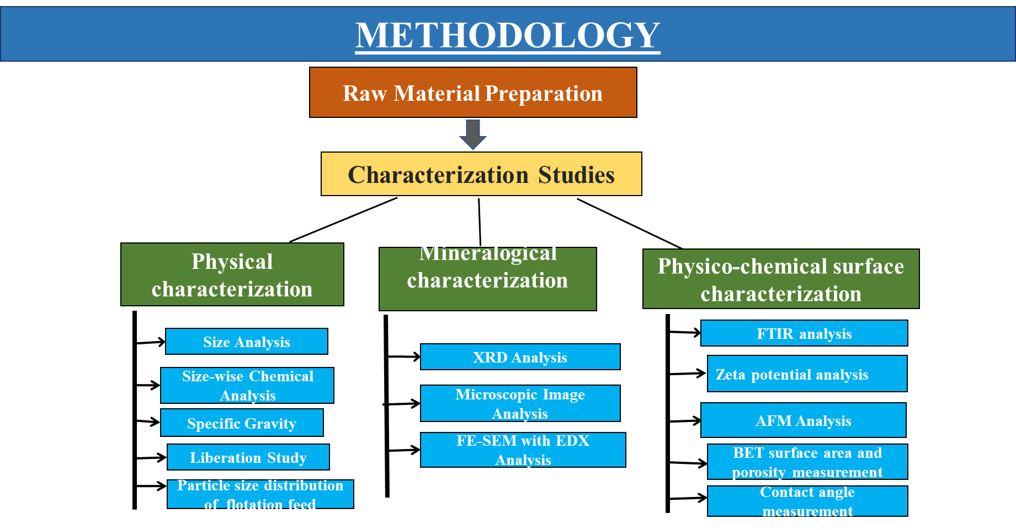

The method of froth floatation can be classified into three steps:
1. True floatation – In this process minerals are selectively attached to froth. This process is very critical and important as the extraction of the valuable minerals is decided by this step only while the other two steps determine the separation efficiency between the mineral and the gangue.
2. Entrainment – Under this process of entrainment air bubbles are passed in liquid water which the froth leads to the generation of air bubbles.
3. Aggregation – In this process, the mineral particles are trapped by the froth.
An important criterion of separation of minerals by the froth floatation method is that the size of the particles of the ores must be very small equivalent to powder form. This is very important because the heavier and bigger particle would require a greater adhesive force without which they would no longer attach to the froth and settle down in the bottom. Thus, separation will not be possible.
Froth flotation is mainly operated under two common techniques:
1. Direct floatation technique – In this method, the mineral sticks to the air bubble and the remaining gangue settles down at the bottom.
2. Reverse floatation technique – In this method, the gangue sticks to the air bubble and ore particle settle down in the bottom
Adsorption
Adsorption is the adhesion of atoms, ions or molecules from a gas, liquid or dissolved solid to a surface.^{[1]} This process creates a film of the adsorbate on the surface of the adsorbent. This process differs from absorption, in which a fluid (the absorbate) is dissolved by or permeates a liquid or solid (the absorbent), respectively.^{[2]} Adsorption is a surface phenomenon, while absorption involves the whole volume of the material, although adsorption does often precede absorption.^{[3]} The term sorption encompasses both processes, while desorption is the reverse of it.
Similar to surface tension, adsorption is a consequence of surface energy. In a bulk material, all the bonding requirements (be they ionic, covalent or metallic) of the constituent atoms of the material are filled by other atoms in the material. However, atoms on the surface of the adsorbent are not wholly surrounded by other adsorbent atoms and therefore can attract adsorbates. The exact nature of the bonding depends on the details of the species involved, but the adsorption process is generally classified as physisorption (characteristic of weak van der Waals forces) or chemisorption (characteristic of covalent bonding). It may also occur due to electrostatic attraction.^{[5]}
Adsorption is present in many natural, physical, biological and chemical systems and is widely used in industrial applications such as heterogeneous catalysts,^{[6][7]} activated charcoal, capturing and using waste heat to provide cold water for air conditioning and other process requirements (adsorption chillers), synthetic resins, increasing storage capacity of carbide-derived carbons and water purification. Adsorption, ion exchange and chromatography are sorption processes in which certain adsorbates are selectively transferred from the fluid phase to the surface of insoluble, rigid particles suspended in a vessel or packed in a column. Pharmaceutical industry applications, which use adsorption as a means to prolong neurological exposure to specific drugs or parts thereof,^{[citation needed]} are lesser known
Adsorption, capability of all solid substances to attract to their surfaces molecules of gases or solutions with which they are in contact. Solids that are used to adsorb gases or dissolved substances are called adsorbents; the adsorbed molecules are usually referred to collectively as the adsorbate. An example of an excellent adsorbent is the charcoal used in gas masks to remove poisons or impurities from a stream of air.
The amount of heat evolved when one mole of the adsorbate is adsorbed on adsorbent is called enthalpy of adsorption. Adsorption is an exothermic process and enthalpy change is always negative. When adsorbate molecules are adsorbed on the surface, freedom of movement of molecules become restricted and this results in decrease in entropy. Adsorption is a spontaneous process at constant pressure and temperature, thus Gibb’s free energy is also decreased.

Types of Adsorption
There are two types of Adsorption – Physical Adsorption or Physiosorption and Chemical Adsorption or Chemisorption.
Physical Adsorption
It involves adsorption of gases on solid surface via weak van der Waal’s forces.

Characteristics of Physical Adsorption
- There is no specificity in case of physical adsorption. Every gas is adsorbed on the surface of the solid.
- Nature of the adsorbate. Easily liquefiable gases are strongly adsorbed physically.
- Physical adsorption is reversible in nature. If pressure is increased volume of gas decreases as a result more gas is adsorbed. So, by decreasing the pressure, gas can be removed from the solid surface. Low temperature promotes physical adsorption and high temperature decreases the rate of adsorption.
- More surface area more is the rate of adsorption. Porous substances and finely divided metals are good adsorbents.
- Physical adsorption is an exothermic process.
- No activation energy is needed.

Chemical Adsorption or Chemisorption
When the gas molecules or atoms are held to the solid surface via chemical bonds, this type of adsorption is chemical adsorption or chemisorption.
Characteristics of Chemical Adsorption
- This type of adsorption is specific as compared to physical adsorption. Adsorption occurs only if there is formation of chemical bonds between the adsorbate and adsorbent.
- Chemical adsorption is irreversible. It is an exothermic process but the process occurs slowly at low temperature. Chemisorption is accompanied by increase in temperature. High pressure promotes chemisorption.
- Chemisorption increases with increase in surface area.
- Due to chemical bond formation enthalpy of chemisorption is high.
- Activation energy is needed.
- It results in unimolecular layer.

Electrical characteristics of interfaces
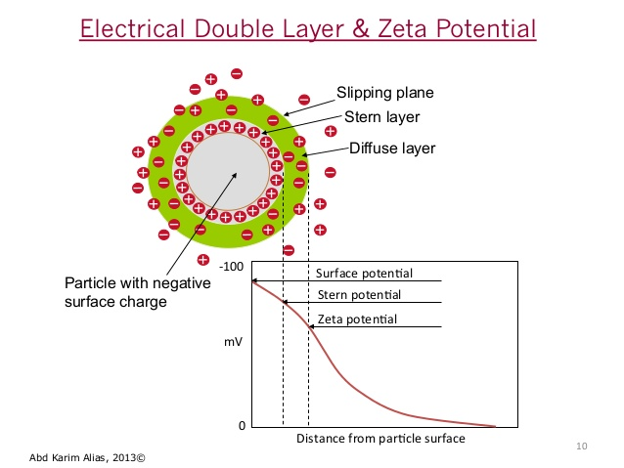

Origin of Surface Charge and Zeta potential
When mineral is suspended in water, charged species/ions (potential determiningions) are transferred upon the surface which develops an electric charge orelectric double layer. In thecase of oxide minerals, H⁺ and OH_ ions are theprincipal potential determining ions, and they interact with water and producesurface hydroxyls.
Due to the charge inequality, a double layer around the particle’s surface iscreated. The potential difference between the stern layer and diffused layer isknown as zeta potential.
At certain pH, an equal number of positive and negative surface sites are created,where the surface is having no specific charge, termed as point of zero charge (PZC).These two terms have great influence on the flotation performance of mineral atspecific pH.
Zeta potential denotes charge properties of particles and in turn implies adsorption,penetration and adherence of certain substances. Processes such as adsorption,particularly surfactants or macromolecules, can alter the interfacial behaviour of thesolids markedly. Adsorption and desorption of potential determining ions (H+ andOH_ ions) play an important role in accounting the surface charge:
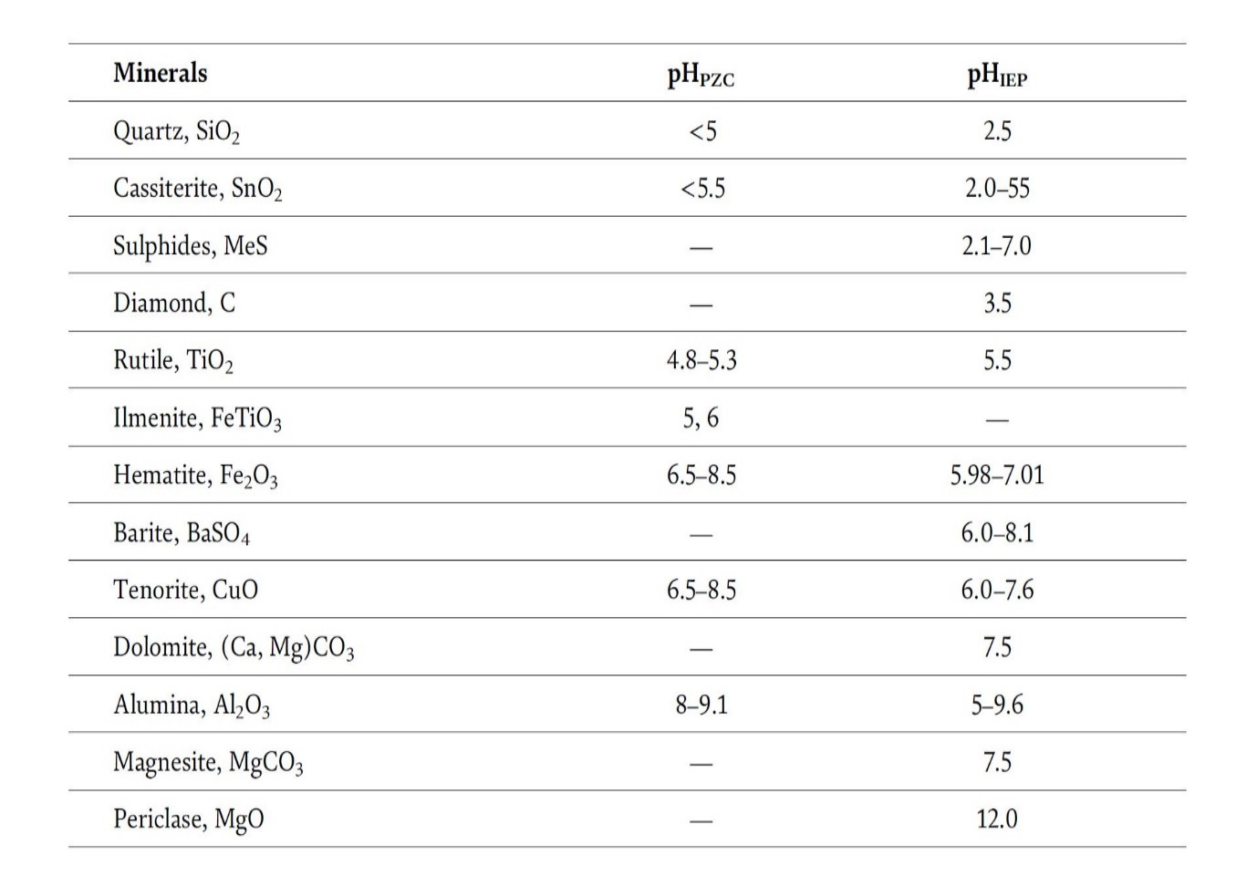

In the case of iron ores, the isoelectric point of natural hematite varies inbetween 5.98 and 7.01, depending upon the association of gangues. If the hematiteparticles are not liberated completely, then isoelectric point will be closer to quartz.The zeta potential of quartz depends on the hydroxylation of quartz surface atdifferent pH values and the interaction of amine species. The pHPZC and pHiepvalues for various oxides and hydroxides of alumina vary widely (pH 5–9.6)depending upon the association of other minerals. The pHiep of quartz is atpH = 2.5, below which it acquires a positive charge, and above this pH, the quartz
surface acquires negative charge
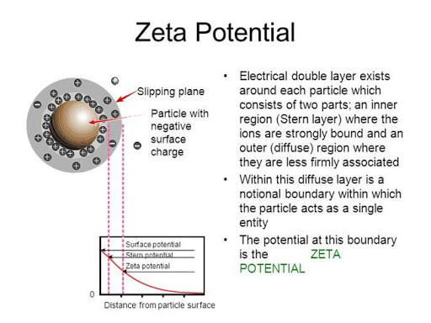
Zeta potential is the electrical potential at the slipping plane. This plane is the interface which separates mobile fluid from fluid that remains attached to the surface.
Zeta potential is a scientific term for electrokinetic potential^{[1][2]} in colloidal dispersions. In the colloidal chemistry literature, it is usually denoted using the Greek letter zeta (ζ), hence ζ-potential. The usual units are volts (V) or millivolts (mV). From a theoretical viewpoint, the zeta potential is the electric potential in the interfacial double layer (DL) at the location of the slipping plane relative to a point in the bulk fluid away from the interface. In other words, zeta potential is the potential difference between the dispersion medium and the stationary layer of fluid attached to the dispersed particle.
The zeta potential is caused by the net electrical charge contained within the region bounded by the slipping plane, and also depends on the location of that plane. Thus, it is widely used for quantification of the magnitude of the charge. However, zeta potential is not equal to the Stern potential or electric surface potential in the double layer,^{[3][4][5][6]} because these are defined at different locations. Such assumptions of equality should be applied with caution. Nevertheless, zeta potential is often the only available path for characterization of double-layer properties.
The zeta potential is a key indicator of the stability of colloidal dispersions. The magnitude of the zeta potential indicates the degree of electrostatic repulsion between adjacent, similarly charged particles in a dispersion. For molecules and particles that are small enough, a high zeta potential will confer stability, i.e., the solution or dispersion will resist aggregation. When the potential is small, attractive forces may exceed this repulsion and the dispersion may break and flocculate. So, colloids with high zeta potential (negative or positive) are electrically stabilized while colloids with low zeta potentials tend to coagulate or flocculate as outlined in the table.
Surface tension and surface activity
Liquid surfaces are known to behave like stretched membranes that make itpossible for small insects like water strider to walk across its surface as if it were asolid substrate. While molecules within the bulk of the liquid experiences no netforce being pulled equally from all possible directions, at an interface it experiencesunbalanced forces arising from the pull from molecules in the liquid layer just belowit that makes the interface behave like a stretched membrane. These forces called thesurface tension act parallel to the plane of the interface and are defined as force perunit length or surface energy per unit area of the interface and are a characteristicof the interface. Typical surface tension at the water-air interface is 72 mN/m,while for the mercury-air interface, it is 456 mN/m.
Surface active molecules or surfactants or amphiphiles as they are often calledconsist of a hydrophilic (water loving, polar) group at one end and a hydrophobic(water hating, nonpolar) group at the other. These molecules are unique inthat when added to water, its surface tension reduces significantly. Thecoexistence of the hydrophilic and hydrophobic end group in the same molecule
allows them to self-organize at interfaces that make them surface active. While the
hydrophilic end remains in contact with water, the hydrophobic end stands out
in air, and the axis of the molecule makes an angle with the plane of the air-water
interface which is a characteristic of the molecule and depends on its molecular
structure and packing at the interface. It is this self-organization of the amphiphile
at the air-water interface that reduces the surface tension of water. It has been
observed that the extent of surface tension lowering depends on several factors,
namely, (a) the structure of the molecule, (b) temperature, (c) electrolyte concentration
of the aqueous phase.

Module-II

Contact Angle and its role in froth flotation
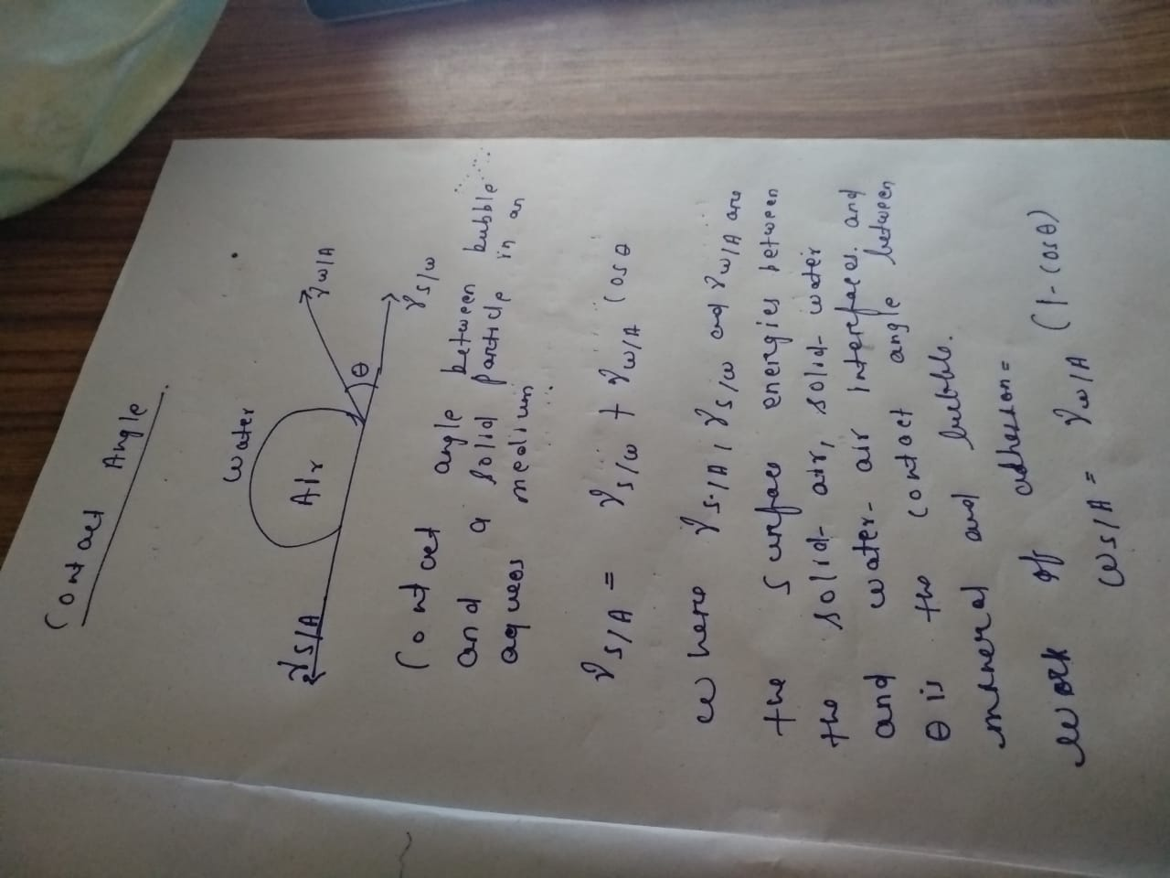
The contact angle is the angle, conventionally measured through the liquid, where a liquid–vapor interface meets a solid surface. It quantifies the wettability of a solid surface by a liquid via the Young equation. A given system of solid, liquid, and vapor at a given temperature and pressure has a unique equilibrium contact angle. However, in practice a dynamic phenomenon of contact angle hysteresis is often observed, ranging from the advancing (maximal) contact angle to the receding (minimal) contact angle.^{[1]} The equilibrium contact is within those values, and can be calculated from them. The equilibrium contact angle reflects the relative strength of the liquid, solid, and vapour molecular interaction.
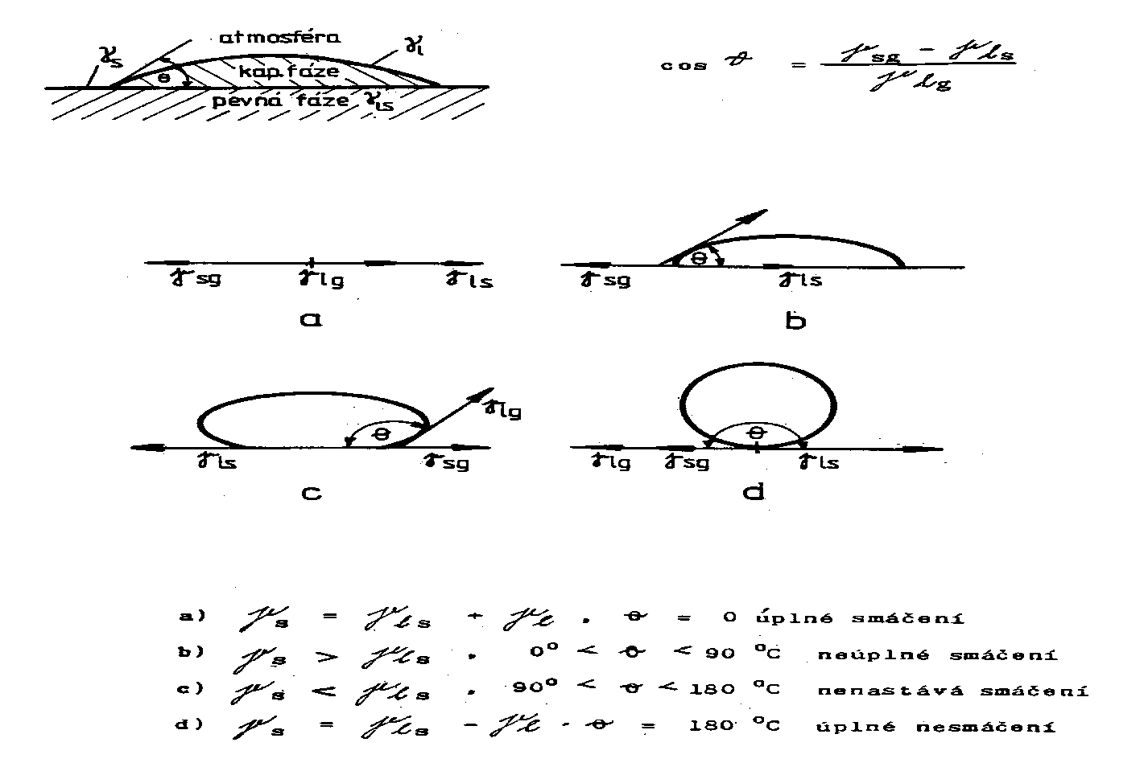

When an interface exists between a liquid and a solid, the angle between the surface of the liquid and the outline of the contact surface is described as the contact angle θ (lower case theta). The contact angle (wetting angle) is a measure of the wettability of a solid by a liquid.
In the case of complete wetting (spreading), the contact angle is 0°. Between 0° and 90°, the solid is wettable and above 90° it is not wettable. In the case of ultrahydrophobic materials with the so-called lotus effect, the contact angle approaches the theoretical limit of 180°.

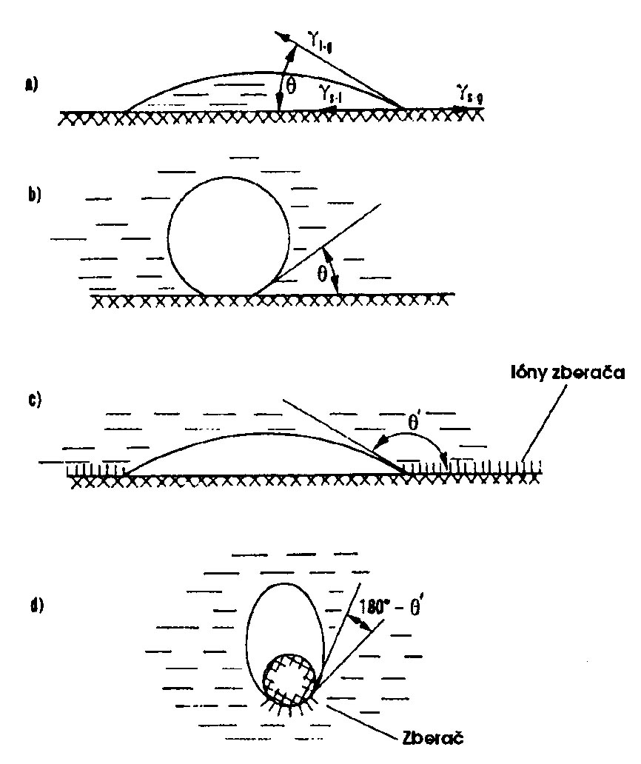

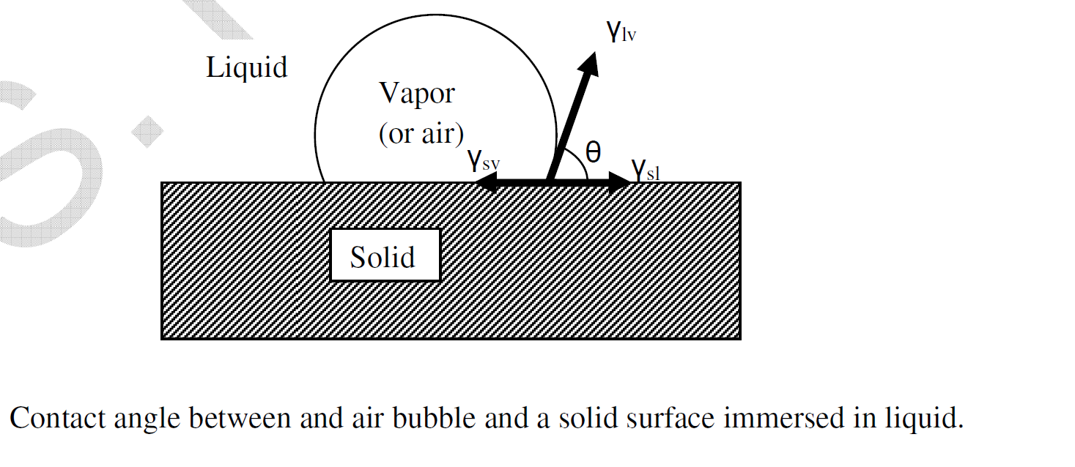
The angle between the tangent to the liquid to surface at the point of contact and solid surface inside the liquid, is called contact angle.

The attachment of the bubbles to the surface is determined by the interfacial energies between
the solid, liquid, and gas phases. This is determined by the Young/Dupre Equation,
γlvcosϴ= (γsv – γsl)
where lv is the surface energy of the liquid/vapor interface, sv is the surface energy of the
solid/vapor interface, sl is the surface energy of the solid/liquid interface, and is the “contact
angle”, the angle formed at the junction between vapor, solid, and liquid phases, as shown in
Figure 4. If the contact angle is very small, then the bubble does not attach to the surface, whilea very large contact angle results in very strong bubble attachment. A contact angle near 90° issufficient for effective froth flotation in most cases.

Work of Adhesion and work of Cohesion
Greater the contact angle, greater the work of adhesion between particle and the bubble and the more resilient the system is to disruptive forces .
Work of Adhesion :
Work done to separate two different phases from each other, is called work of adhesion.
The work of adhesion is a measure of the strength of the contact between two different phases.
Work of Cohesion :
The work of cohesion specifies the work which must be expended to produce droplets from a volume of liquid when spraying. If the work of cohesion is larger, the liquid does not spread; if the work of adhesion is larger, the liquid spread
Attractive forces between molecules of the same type are called cohesive forces. Liquids can, for example, be held in open containers because cohesive forces hold the molecules together. Attractive forces between molecules of different types are called adhesive forces. Such forces cause liquid drops to cling to window panes, for example. In this section we examine effects directly attributable to cohesive and adhesive forces in liquids.

Surface Tension

Cohesive forces between molecules cause the surface of a liquid to contract to the smallest possible surface area. This general effect is called surface tension. Molecules on the surface are pulled inward by cohesive forces, reducing the surface area. Molecules inside the liquid experience zero net force, since they have neighbors on all sides.
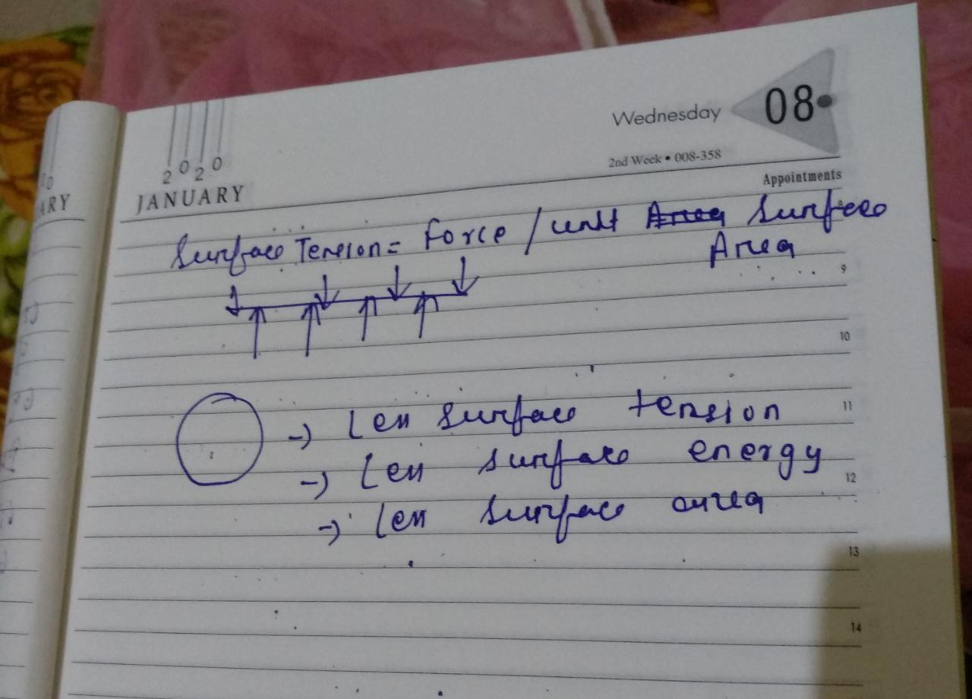

Interface
Interface is the boundary between two or more phases exist together q The properties of the molecules forming the interface are different from those in the bulk that these molecules are forming an interfacial phase. Several types of interface can exist depending on whether the two adjacent phases are in solid, liquid or gaseous state.

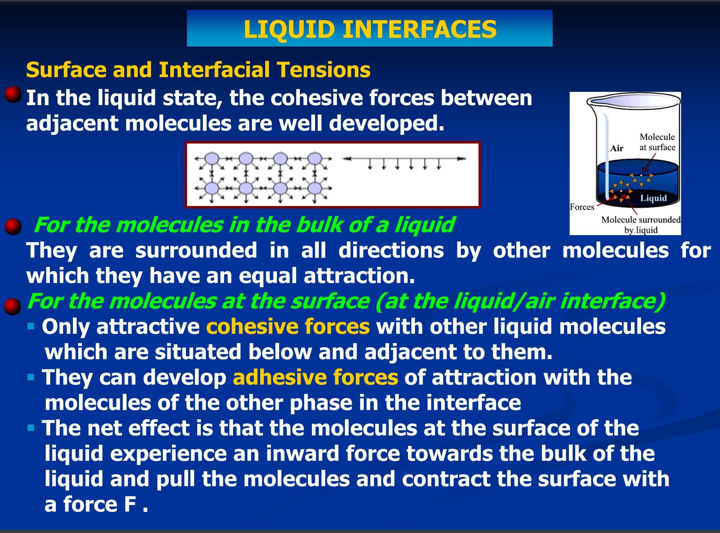

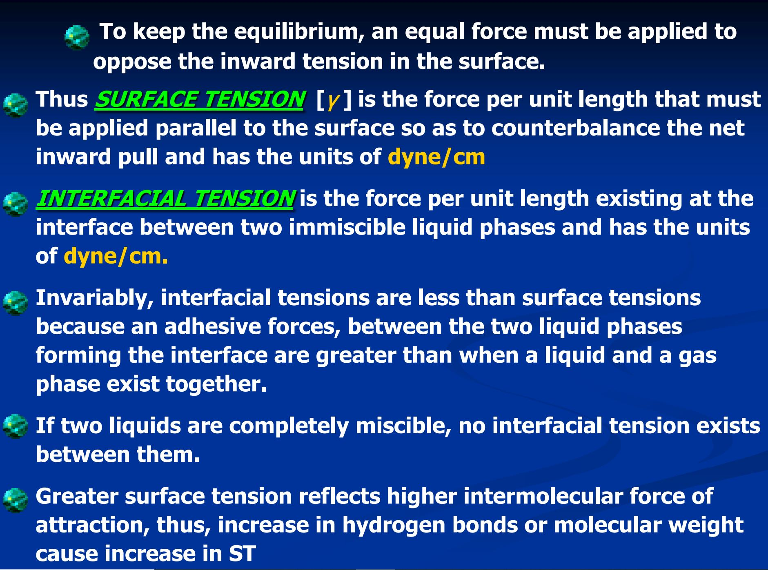
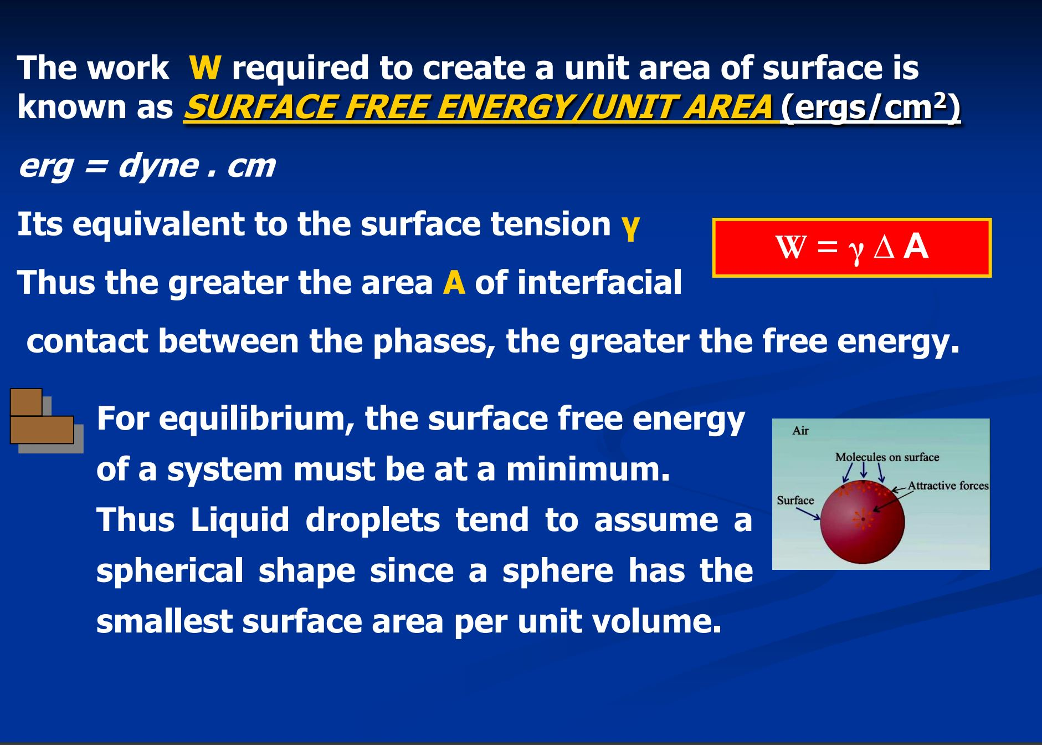
adhesive forces:
the attractive forces between molecules of different types
capillary action:
the tendency of a fluid to be raised or lowered in a narrow tube
cohesive forces:
the attractive forces between molecules of the same type
contact angle:
the angle θ between the tangent to the liquid surface and the Solid surface
surface tension:
the cohesive forces between molecules which cause the surface of a liquid to contract to the smallest possible surface area

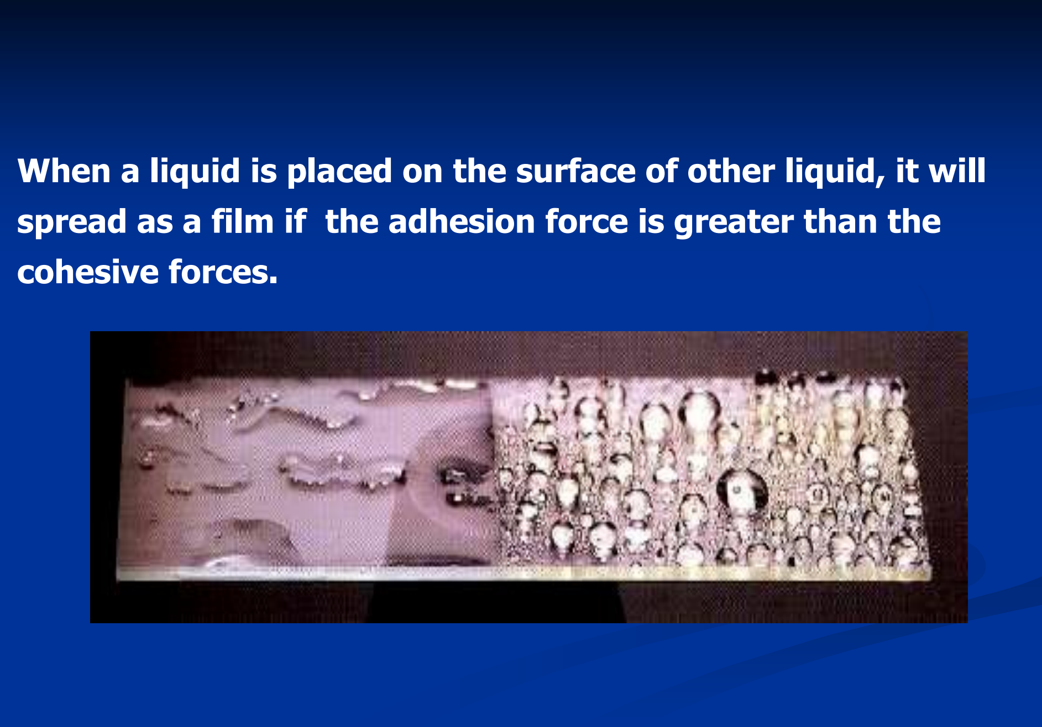

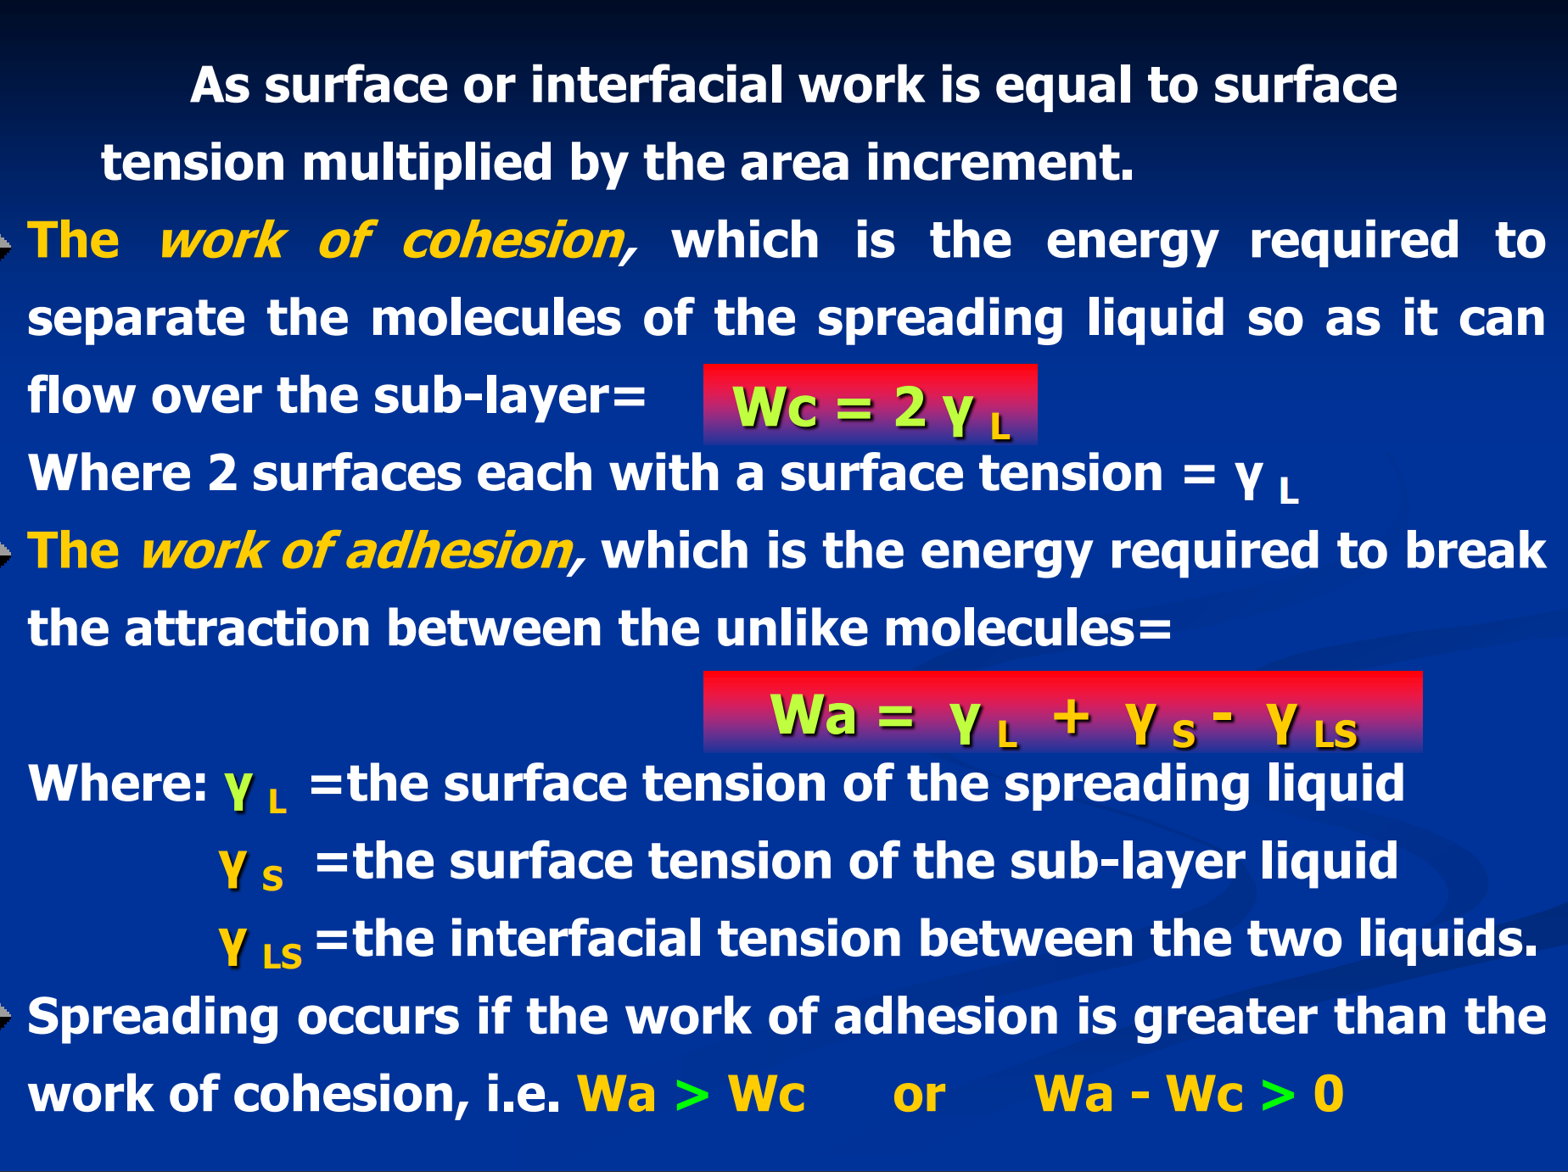

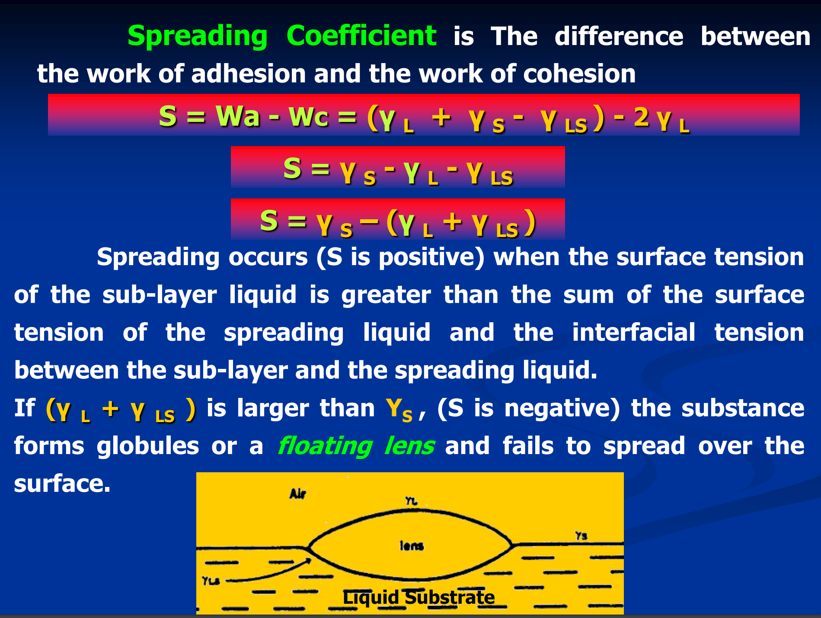

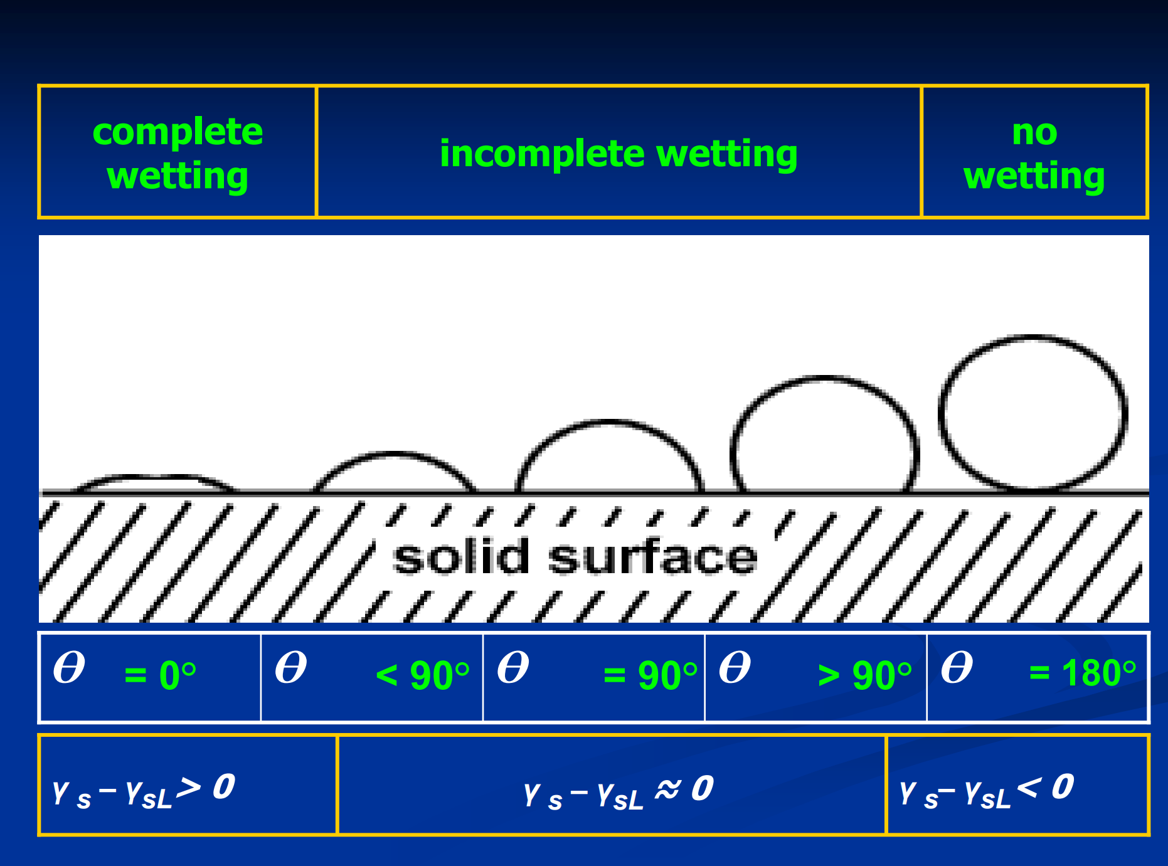

Reagents

The properties of raw mineral mixtures suspended in plain water are rarely suitable for froth flotation. Chemicals are needed both to control the relative hydrophobicitiesof the particles, and to maintain the proper froth characteristics. There are therefore many different reagents involved in the froth flotation process, with the selection of reagents depending on the specific mineral mixtures being treated. (Klimpel,1995).

Hydrophobicity and hydrophilicity

The basis of froth flotation is the difference in wettabilities of different minerals. Particles rangefrom those that are easily wettable by water (hydrophilic) to those that are water-repellent(hydrophobic). If a mixture of hydrophobic and hydrophilic particles are suspended in water,and air is bubbled through the suspension, then the hydrophobic particles will tend to attach tothe air bubbles and float to the surface. The froth layer that forms on thesurface will then be heavily loaded with they hydrophobic mineral, and can be removed as aseparated product. The hydrophilic particles will have much less tendency to attach to airbubbles, and so it will remain in suspension and be flushed away (Whelan and Brown, 1956).
Particles can either be naturally hydrophobic, or the hydrophobicity can be induced by chemicaltreatments. Naturally hydrophobic materials include hydrocarbons, and non-polar solids such aselemental sulfur. Coal is a good example of a material that is typically naturally hydrophobic,because it is mostly composed of hydrocarbons. Chemical treatments to render a surfacehydrophobic are essentially methods for selectively coating a particle surface with a monolayerof non-polar oil.

Hydrophobic particles in froth flotation
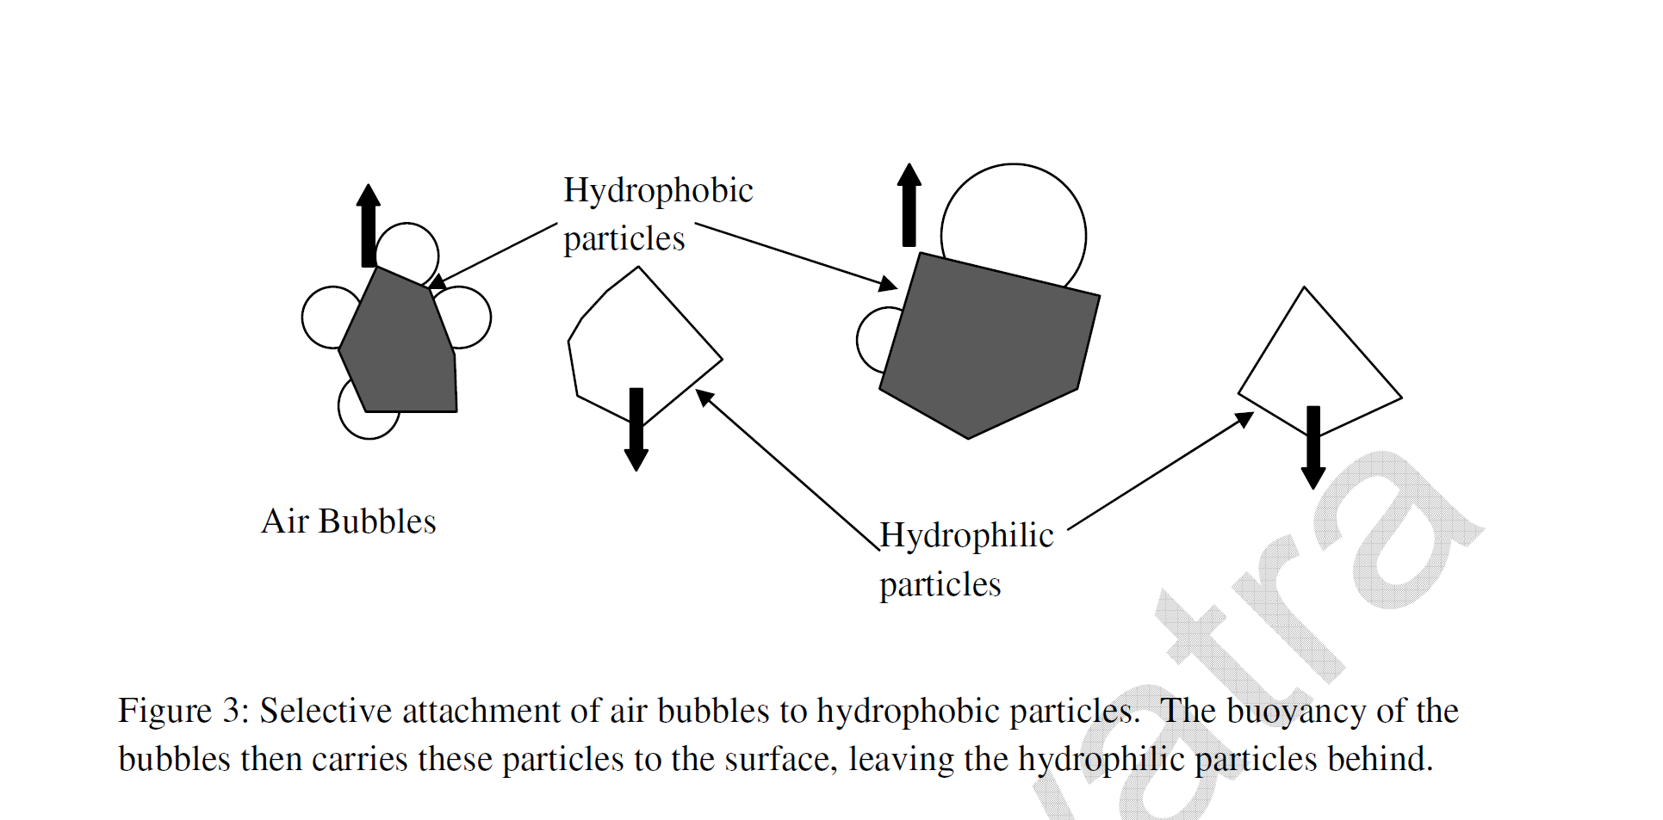

- Render minerals hydrophobic by attaching to thesurface
of mineralparticles.
- A collector’s polar head will attach to a polar mineral surface, leaving the nonpolar tails toward the surrounding water molecules, rendering the mineral hydrophobic,
Fig 2: interaction of collector with mineralsurface

- Produces stable bubbles for hydrophobic particles to attach.
- When the mineral surfaces havebeen rendered hydrophobic by the collector, the frother is meant to produce a stable bubble. Frothers alsoact as collectors, which can lead to decreasedselectivity.
- Some collectors are such good frothers as well that they stabilize the froth so much as to reduce their transportability.
- Example frothers include pine oil and MIBC (methyl isobutylcarbinol).
Bubble Particle Attachment
- (1) Initially air bubbles are fully loaded with floatable particles as the total of area of bubble surfaces is less than the area required for floatable particles. This condition is described as inhibited/explosive/loaded flotation.
(2) After some time air bubbles are sparsely loaded as the total of area of bubble surfaces is more than what is required by the floatable particles at a particular time. This condition is described as free flotation.
(3)Transitional flotation is where all the conditions of (1) and (2) may exist.

v
v
v
v
v
v

Regulators, or modifiers, are used extensively in flotation to modifythe action of the collector, either by intensifying or by reducing its water-repellent effect on the mineralsurface.
Regulators can be classed
as activators, depressants, or pHmodifiers.Dispersants

Regulators, or modifiers, are used extensively in flotationto modifythe action ofthe collector, either by intensifying or by reducing its water-repellent effect on the mineralsurface.
regulatorscanbe classed
as activators, depressants, or pHmodifiers.Dispersants

- These reagents alter the chemical nature of mineral surfaces so that they become hydrophobic due to the action of thecollector.
- Activators are generally soluble salts which ionisein solution, the ions then reacting with the mineral surface.
A classicalexample is the activation of sphalerite by copper insolution

ZnS+Cu2. CuS+ Zn2+

- Depression is used to increase the selectivity of flotation by rendering certain minerals hydrophilic (water-avid), thus preventing theirflotation.
- They are key to the economic flotation of certain ores such as platinum and nickelsulphides.
There are many types of depressants and their actions are complex and varied, and in most cases not fully understood, making depression more difficultto control than the application of other types of reagent, particularly when theFroth phase is also affected by their action.

Conditioning

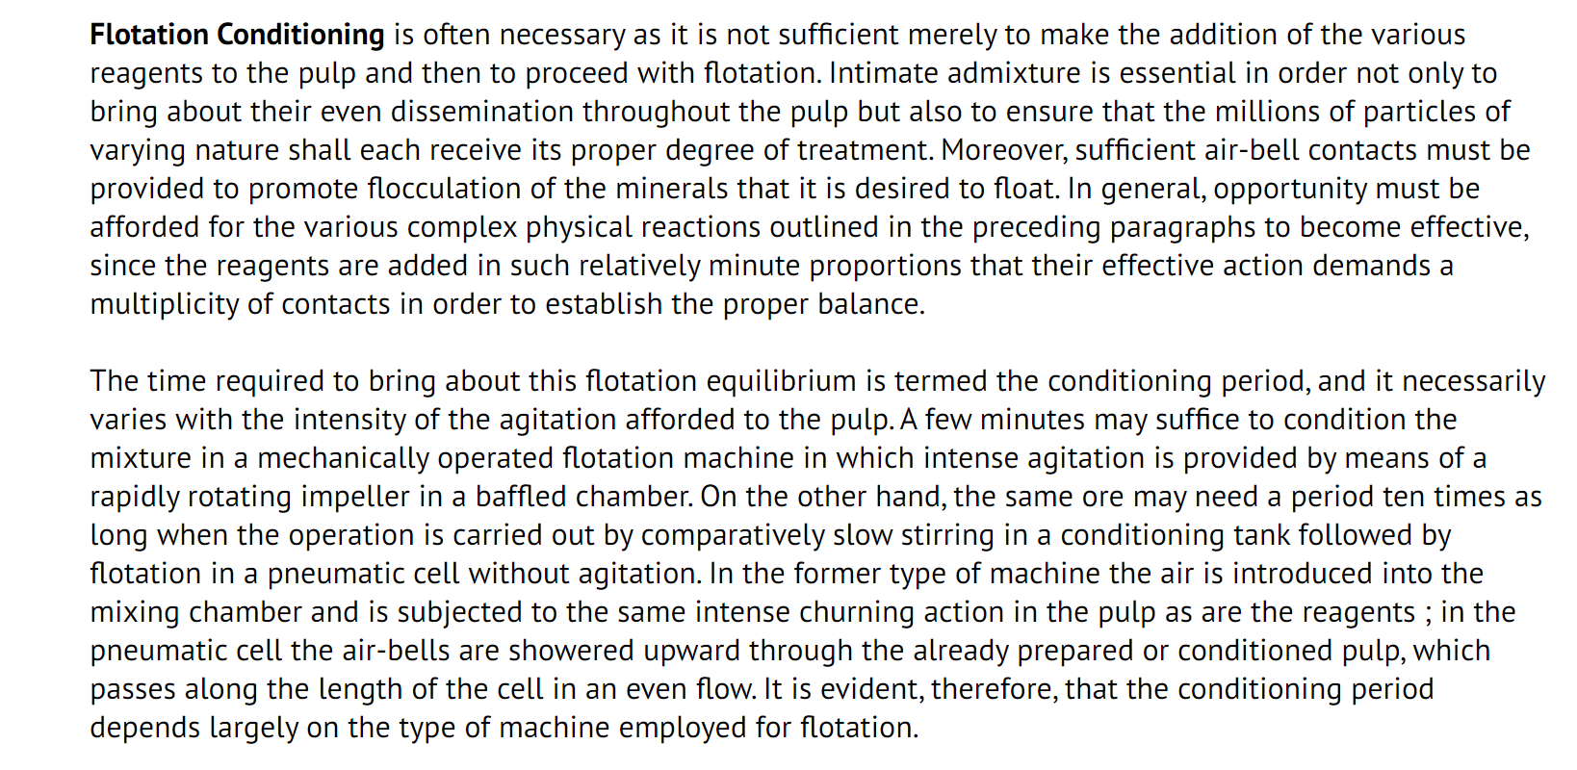

Conditioning in Flotationcells

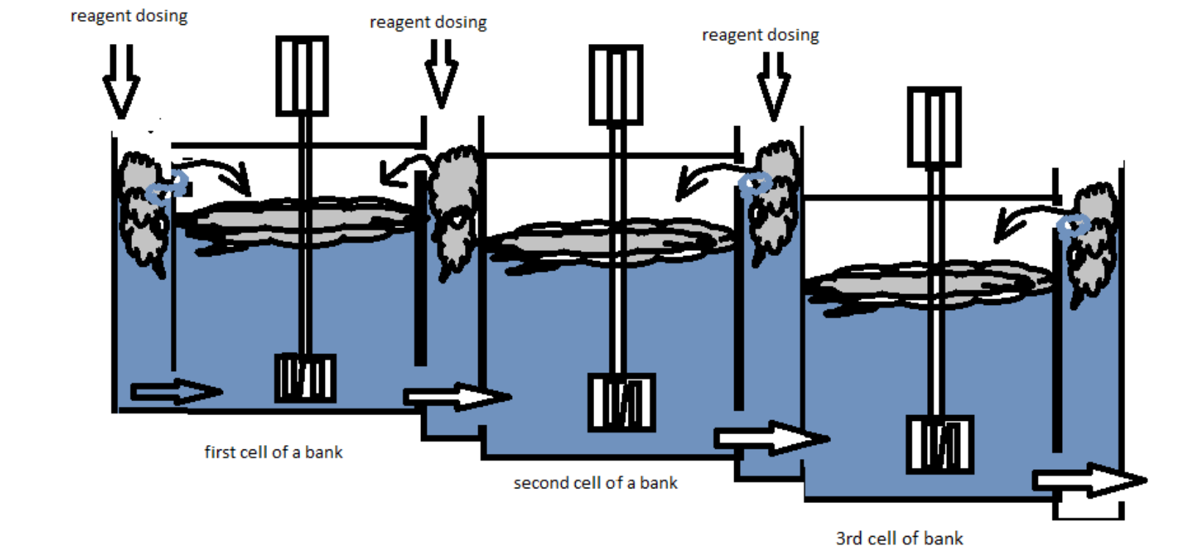

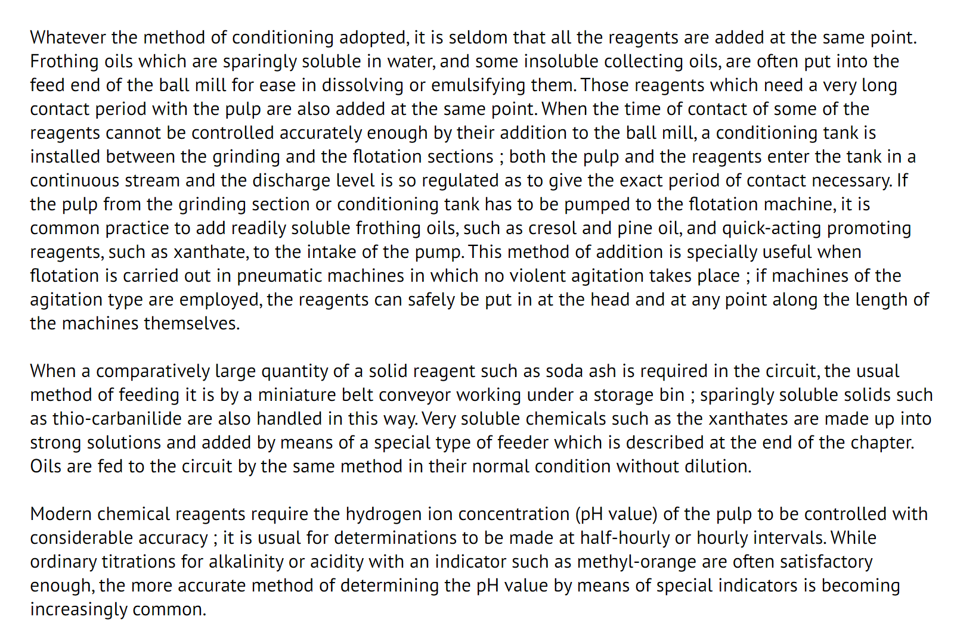
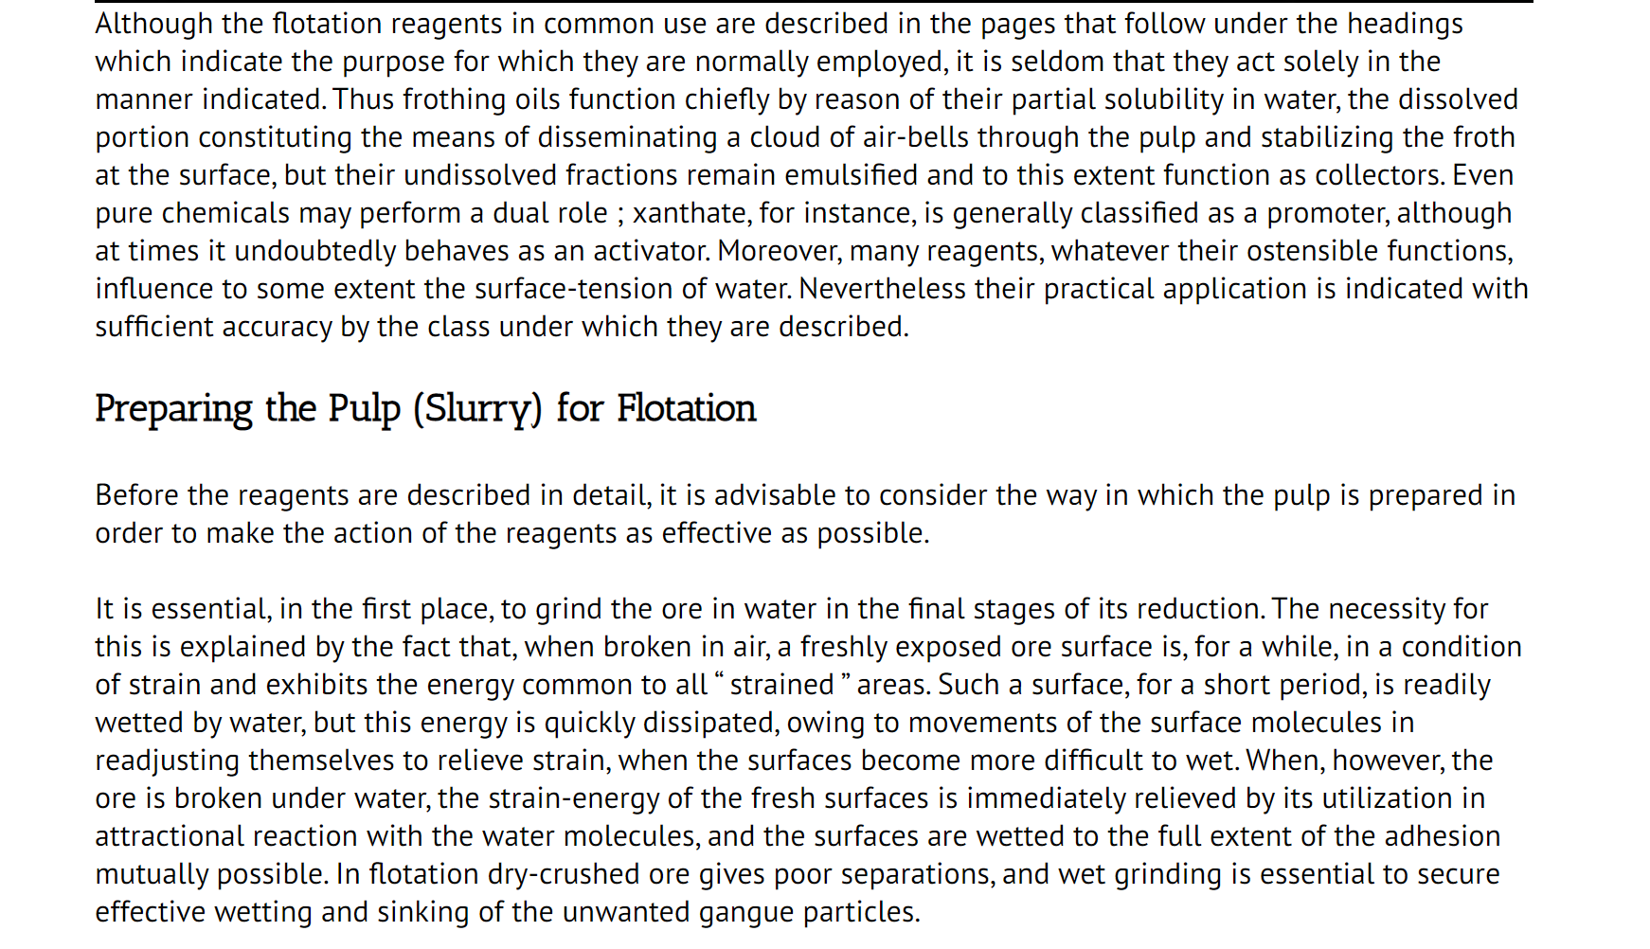
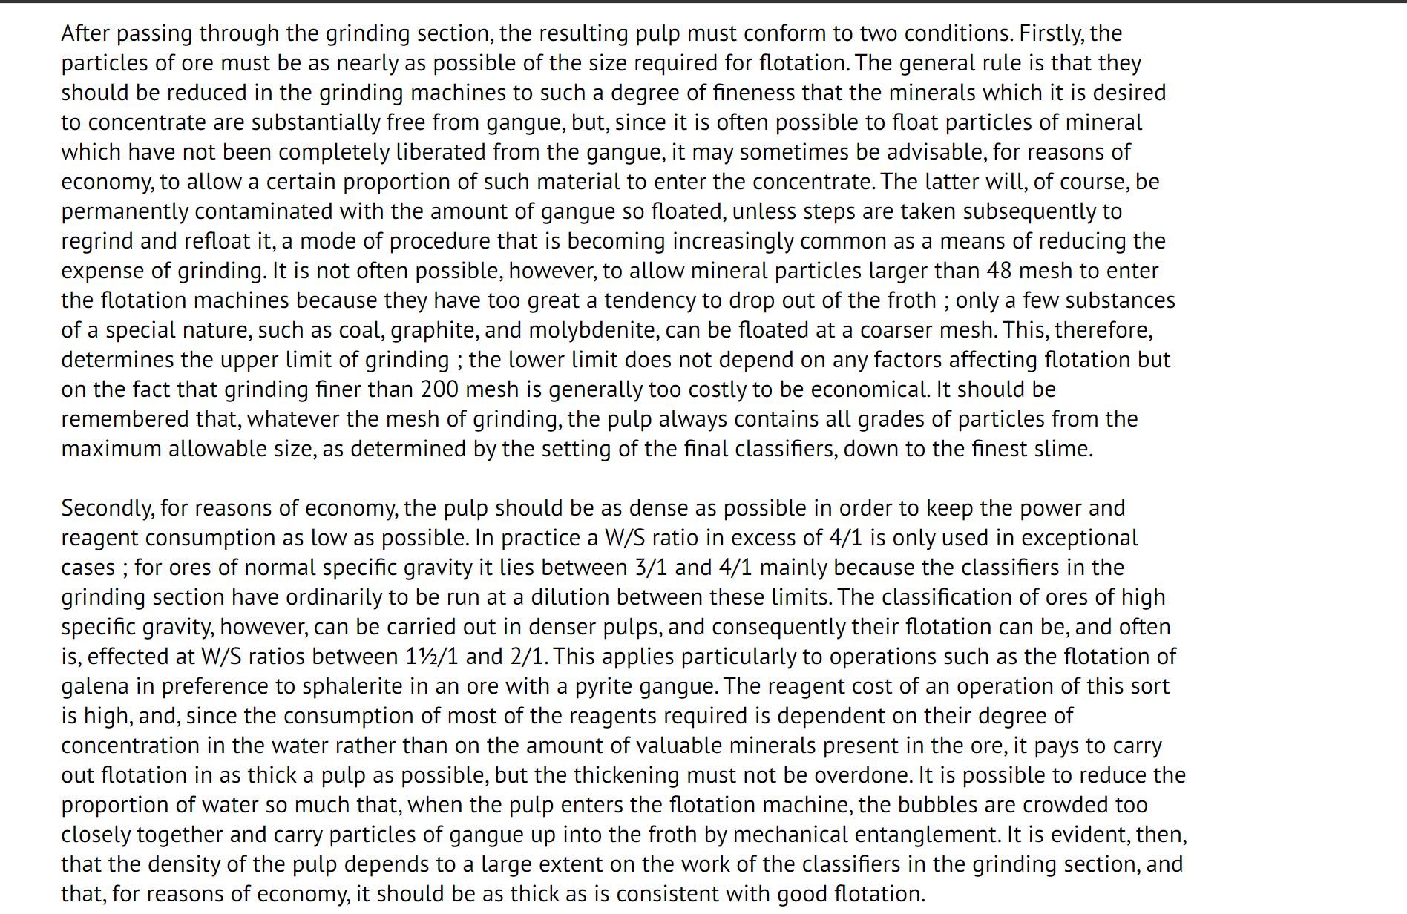

Reagents used in froth flotation

Collectors

Collectors are reagents which render minerals’ surface hydrophobic by adsorption. The selection of an appropriate collector is critical for selective separation of valuable minerals from gangue minerals. Collectors can be classified into non-ionic, anionic and cationic depending on their ionic charge and active ion participation.
The non-ionic collectors are simply hydrocarbon oils, while the cationic collectors have a positively charged active functional group and anionic collectors have a negatively charged active functional group. The collectors can be adsorbed on the mineral surface by either of the following mechanism.
A) Chemisorption

Chemisorption occurs in the inner Stern layer of the electrical double layer. It involves the complete or partial transfer of electrons. Adsorption through chemisorption involves the chemical interactions between the cations and the mineral surfaces through the formation of ion complexes, which is irreversible. In addition to the chemical bonds, hydrogen bonds can be formed when the mineral surface and collectors contain hydroxyl and amine groups (weak chemisorption) (Bulatovic, 2007).

B) Physisorption

Collectors adsorb via ion exchange or electrostatic attraction, where no true bonds are formed and are reversible. The physisorption is typically observed at low surfactant concentrations and when the surface charge density of mineral is comparatively less. Physical adsorption occurs in the outer Stern layer of the electrical double layer. The most common interactions present in physical adsorption are ions or molecules held in the outer stern layer through electrostatic or dispersion forces or a combination of both (Patridge and Smith, 1971).

Frothers

The role of frothers is to stabilize air bubbles so that they will remain well dispersed in the slurry and will form a stable froth layer that can be removed before collapsing. The most commonly used frothers are alcohols. Particularly Methyl Isobutyl Carbinol (MIBC) or water-soluble polymers such as polypropylene glycols derived from propylene oxide (PO), cresols and pine oils.

Modifiers

Modifiers are chemicals that are added during flotation which influence the conditions for the selective adsorption of collectors on the desired mineral surface. They may either increase the adsorption of collector onto a given mineral (activators) or prevent the collector from adsorbing onto a mineral not to float at that instance (depressants). Modifiers also include pH regulators.

pH regulators

The surface chemistry of most minerals is affected by the pH of the slurry. The acids such as sulphuric acid, hydrochloric acid and bases like sodium hydroxide, calcium oxide acts as pH regulators to create a pulp of acidic or alkaline pH.

(b) Activators

Activators are specific compounds that make it possible for collectors to adsorb onto surfaces that they could not normally attach to. Soluble salts interact with the mineral surface, promoting collector adsorption and, in turn, mineral hydrophobicity.

(c) Depressants

A depressant plays the role of making specific minerals hydrophilic during flotation, thus keeping them in the flotation pulp. Different depressants act differently on the different mineral surface due to their varied form, chemical composition and behaviour.

Zones of flotation

A flotation system consists of three distinct zones and two phases, each characterized by different physical and chemical processes. The zones are namely, agitation, transportation and froth zone and phases are namely the pulp phase and the froth phase. In the pulp phase, the milled ore slurry mixture, conditioned with different reagents. Consequently, attachment occurs in the pulp zone and the mineral-bubble aggregate moves up to the froth phase against gravity whilst the hydrophilic substance remains in the pulp (Yianatos and Contreras, 2009).

In a flotation cell, minerals reach the froth phase by two methods, viz, true flotation and entrainment. True flotation is the selective attachment of mineral particles to bubbles. It is brought about by the effective actions of collector and depressants (Wise et al., 2005). Entrainment, on the other hand, is non-selective and undesirable and thus results in the reporting of the gangue along with the valuable minerals to the froth zone during direct flotation. Recovery by entrainment is affected by particle size and density as well as the recovery of water into the froth. It has been inferred that the factors that affect the froth phase can also result in entrainment (Robertson, 2003).

